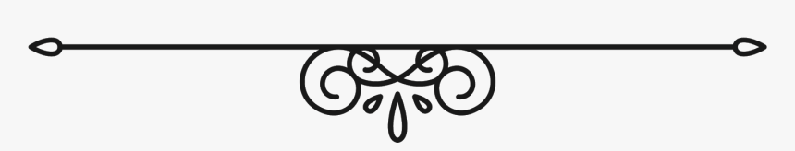**Lighthouse Restaurant**

Starters

Bowl of mixed bread rolls and butter with balsamic and olive oil dip - £3.95

Homemade French onion soup served with a cheese topped crouton - £5.95

Spicy chicken wings of fire served with a bourbon barbecue sauce - £7.95

Lamb kofta served with a mint yoghurt dip - £7.50

Homemade chicken liver pate served with crostini and red onion chutney - £7.50

King prawn cocktail served with wholemeal bread - £8.95

Citrus and herb crusted King scallops - £8.50

Roasted pepper stuffed with Moroccan couscous - £6.95

Wild mushroom tart served with red onion chutney - £7.95

To Share

Fried fish sharing board including Scampi, Calamari and Whitebait - £11 .95

Main courses

Turkey roulade with sausage and sage and onion stuffing, wrapped in pancetta served with baby roast potatoes, gravy and braised red cabbage - £13.99

8oz fillet steak served with chunky gourmet chips, grilled tomato, mushrooms and a homemade pepper sauce - £29.95

Homemade pork, bratwurst sausage and mixed bean cassoulet with dauphinoise potatoes - £17.95

6oz gourmet burger served with cheese, crispy bacon, lettuce, tomato and onion rings with a side of fries and coleslaw - £14.95

Corn fed breast of chicken served in a wild mushroom, baby leek and tarragon cream sauce and rosti potatoes - £16.50

Seared calves liver served on a bed of champ mash with a onion and pancetta red wine jus - £ 15.95

Roasted cod loin served with cherry vine tomatoes and thyme and roasted baby new potatoes - £16.95

Prawn, courgette and lemon tagliatelle served with garlic and herb bread - £13.95

Wing of skate served with paprika and lemon butter, served with sauté potatoes

Subject to market price please ask your server for price

Vegan tikka kebabs served with basmati rice and mango chutney - £12.95

Butternut squash and sage risotto served with truffle oil dressing and parmesan shavings - £13.95

Sides

Chips/Onion Rings/Salad/Steamed Vegetables - £3.50

**Dessert menu**

Biscoff cheesecake served with coffee liqueur cream - £7.25

Rockfall brownie served with salted caramel ice cream and chopped walnuts - £7.40

Lemon meringue roulade served with fruits of the forest - £6.40

Warm apple tart served with Devonshire custard - £6.50

French style macaroons served with chocolate ice cream and chopped pistachios - £7.50

Trio of cheese board with biscuits, chutney, grapes and celery - £7.95

A selection of ice creams and sorbets available - £5.50

